Training for Attaching JAS Seals through a Consignment Contract
► By completing this training document you satisfy the required training for attaching (grading) Organic JAS labels, set forth in Section V of “The Technical Criteria for Certifying Importers of Organic Plants and Organic Processed Foods of Plant Origin”.
- Types of organic products that can have the JAS Organic seal attached through consignment contracts with JAS certified importers
- Organic plants (including fungi)
  - For example: vegetables, fruits, grains, fresh coffee beans, sugar cane, fungi
- Organic processed foods of plant origin (except for organic processed products with a weight of more than 5% livestock products)
  - For example: processed vegetables, processed fruits, processed grains, coffee beans, sugar, black chocolate, tea
- Other types of organic products than (1) and (2) above are not allowed to have the JAS Organic seal attached through a consignment contract.
- Process for attaching JAS Organic Seals to organic products
- Appoint a single person in charge of overseeing and attaching the seals.
  - In order to enter into a consignment contract with a JAS certified importer to attach JAS Organic seals, a single person needs to be appointed to oversee the attaching of the seals.
  - The person in charge needs to understand the types of organic products that can have JAS Organic seals attached, the layout and formatting of the seal, and the process for creating and sending recordkeeping documents to the JAS certified importer.
- Confirm the layout and formatting of your importer’s JAS Organic seal
  - JAS Organic seals must follow the layout and formatting of the image below. The name of the Registered Certifying Body (RCB) who certified the certified importer needs to be included directly below the seal. Only JAS Organic seals that have been specified by the certified importer for use in the consignment contract are allowed to be used.
- Diagram: Layout and Format of the JAS Organic seal
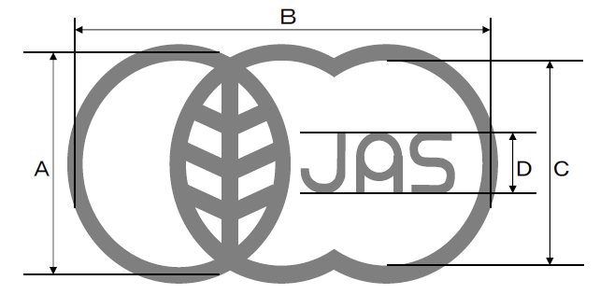
Name of RCB of Importer
- A is longer than 5mm.
- B is twice as long as A.
- D is three-tenths of C.
- The height of the name of the RCB is the same height as D.
- The name of the RCB can be written in its abbreviated form as directed by the certified importer.
- The color of the JAS Organic seal is not specified.
- Different certified importers may be certified by different Registered Certifying Bodies, and thus will require a different RCB name on the seal.
  - If you have consignment contracts with more than one certified importer, it is important to get the correct seal layout from each certified importer.
  - You must use the correct seal for the specific certified importer that the shipment is being exported to.
- Submit the new labels used for international sales to CCOF.
- Requirements for Recordkeeping and Reporting after attaching JAS Organic Seals
- Every shipment to a certified importer that has organic products with an attached JAS Organic seal will need to be documented and reported to the certified importer.
  - The record must include each lot number, names of products shipped, quantities, shipping dates, number of seals attached, and dates that the seals were attached for each product.
  - The record for each shipment needs to be sent along with the shipment to the certified importer for their records.
  - A copy of these documents also needs to be kept by the certified operator attaching the logos.
  - These recordkeeping documents may be kept in electronic format.
- If the number of attached Organic JAS logos is indicated on the original invoice of sale (i.e. by stating that the number of attached JAS logos is the same as the quantity of organic products, or if different than this, a specific number of attached Organic JAS logos is listed), the recordkeeping report does not need to be shipped to the importer. It still needs to be kept by the exporter, and made available at the request of the importer or their registered certifying body.
- An example of the required recordkeeping document that must be created for each shipment is shown below. Templates for this document are available from CCOF.
- Example of a report to the JAS certified Importer
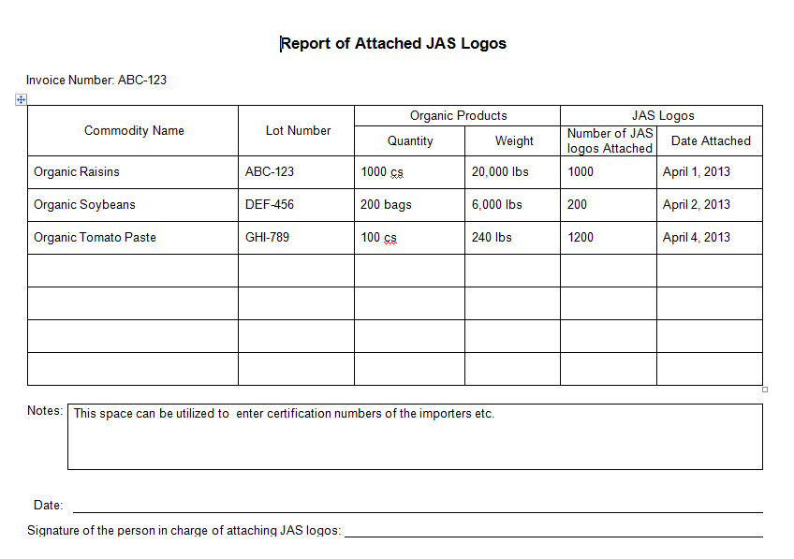

- Supplemental Information
  - Certified operators in the United States who contract with JAS certified importers can attach the USDA Organic seal, CCOF seal, etc. to their organic products being shipped in addition to the Organic JAS logo.
- JAS Organic Seal Consignment Contract Checklist
Contact your Certified Importer in Japan and Sign the Contract of Consignment for Attaching Organic JAS Logos. Each party should keep a copy of the contract.
Complete this training and send to your importer for their records. Keep a copy for yourself as well.
Obtain your importer’s Organic JAS seal/logo.
Submit the new labels for international sales to CCOF.
Apply the Organic JAS Logo to the products that your importer has requested.
Create a recordkeeping document for each shipment that includes the product name(s), the weight and quantity of all products, the lot number(s), the number of JAS logos attached in each shipment, as well as the dates that they were attached
Send your shipment to your importer along with a TM-11 document for export to Japan and the recordkeeping document for that shipment.
- Training Agreement
- By signing this training contract I, the exporter, agree to follow all directions for attaching JAS Organic Seals.
Exporter’s operation name:
Person in charge of attaching JAS Organic seals:
Signature:
Date:
- By signing this training document I, the importer, agree that this document satisfies the training requirement for attaching JAS organic seals through a consignment contract.
Importer’s operation name:
Signature:
Date:

